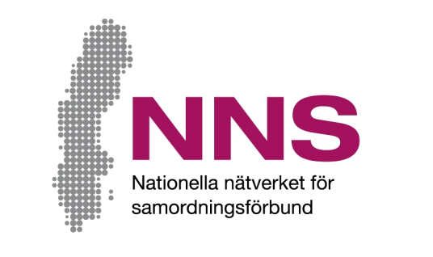
[Space for coordination agency’s own logotype. Remove this text box if no own logotype is used.]
Name of activity: [name of activity]

How do we ensure that improvements are made?
You are participating in an activity financed by a coordination agency. We want to know how you feel the support you are receiving in the activity is working. The purpose is to improve the activity. Your opinions are welcomed!

This questionnaire consists of seven questions. Please attempt to answer all of the questions as openly and honestly as possible. It is entirely up to you whether or not you answer the questions and you do not need to give any reason should refuse to do so, nor if you choose to return a blank questionnaire. Please return the questionnaire in the envelope provided.

All responses will be handled anonymously and all information provided will be anonymized. This means that no individual person can be identified.
If you have any questions or opinions about the questionnaire or how answers will be compiled, please contact:

[Name of contact person]
[Contact person’s function and coordination agency’s name]
Telephone: [telephone number], e-mail: [e-mail address]
Jonas Wells
Developer and manager of NNS Indicators, Nationella Nätverket för Samordningsförbund (National Network for Coordination Agencies)
Telephone: +46 (0)70 638 06 17, e-mail: jonas.wells@nnsfinsam.se
In addition to this written information about the study, you are welcome to ask questions in conjunction with answering the questionnaire.

Thank you for your participation!

Participant questionnaire
The purpose of this questionnaire is to find out how well you feel that the support you are receiving in conjunction with the activity is working.
Please tick the box that best describes how much you agree with each statement.

The questions deal with the extent to which you feel that:
- The support offered is organised around your needs
- You have the influence and time you need
- Someone is available to coordinate your various contacts with public authorities
- You feel that you have taken steps to bring you closer to the labour market/self-sufficiency

About you: | Female □ | Male □ | Prefer not to answer/neither of the above □

 |  |  |  | Never | Seldom | Some-times | Often | Mostly | Always
1 |  | Are you receiving support in a manner that greatly benefits you? |  | □ | □ | □ | □ | □ | □
2 |  | Do you participate in deciding what support you should receive? |  | □ | □ | □ | □ | □ | □
3 |  | Is the support provided allowed enough time? |  | □ | □ | □ | □ | □ | □
 | 4 |  | Do you have one person or one team that you can turn to with your questions and needs? |  | Yes □ |  | No □
 |  | Not at all | Only slightly | Partly | To a large extent | To a very large extent | Completely
5 | Has the support you received helped you to manage your situation? | □ | □ | □ | □ | □ | □
6 | Do you feel more prepared to begin working or studying? | □ | □ | □ | □ | □ | □
7 | Have staff made use of your experience, knowledge and points of view? | □ | □ | □ | □ | □ | □

