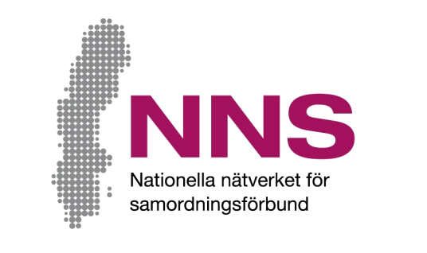
[Space for coordination agency’s own logotype. Remove this text box if no own logotype is used.]
Name of activity: [name of activity]

How do we ensure that improvements are made?
You have participated in an activity financed by a coordination agency. We would like to know about your experience of the support you received and whether you think it worked well. The purpose is to improve the activity. Your opinions are welcomed!

This questionnaire consists of 10 questions. Please attempt to answer all of the questions as openly and honestly as possible. It is entirely up to you whether or not you answer the questions and you do not need to give any reason should refuse to do so, nor if you choose to return a blank questionnaire. Please return the questionnaire in the envelope provided.

All responses will be handled anonymously and all information provided will be anonymized. This means that no individual person can be identified.
If you have any questions or opinions about the questionnaire or how answers will be compiled, please contact:

[Name of contact person]
[Contact person’s function and coordination agency’s name]
Telephone: [telephone number], e-mail: [e-mail address]
Jonas Wells
Developer and manager of NNS Indicators, Nationella Nätverket för Samordningsförbund (National Network for Coordination Agencies)
Telephone: +46 (0)70 638 06 17, e-mail: jonas.wells@nnsfinsam.se
In addition to this written information about the study, you are welcome to ask questions in conjunction with answering the questionnaire.

Thank you for your participation!

Participant questionnaire
The purpose of this questionnaire is to find out how well you feel that the support you received in conjunction with the activity has worked.
Please tick the box that best describes how much you agree with each statement.

The questions deal with the extent to which you feel that:
- The support offered has been organised with your needs in mind
- You have been given the influence and time you needed
- Someone has been available to coordinate your various contacts with public authorities
- You feel that you have taken steps to bring you closer to the labour market/self-sufficiency

About you: | Female □ | Male □  | Prefer not to answer/neither of the above □  

 |  |  |  | Never | Seldom | Some-times | Often | Mostly | Always
1 |  | Have you received support in a manner that was of great benefit to you? |  | □ | □ | □ | □ | □ | □
2 |  | Have you been given the opportunity to decide what support you receive/received? |  | □ | □ | □ | □ | □ | □
3 |  | Has the support provided been allowed to continue for the  necessary amount of time? |  | □ | □ | □ | □ | □ | □
 | 4 |  | Have you had one person or one team that you were able to turn to with your questions and needs? |  | Yes □ |  | No □
 |  | Not at all | Only slightly | Partly | To a large extent | To a very large extent | Completely
5 | Has the support you received helped you to manage your situation? | □ | □ | □ | □ | □ | □
6 | Do you feel more prepared to begin working or studying? | □ | □ | □ | □ | □ | □
7 | Have staff made use of your experience, knowledge and points of view? | □ | □ | □ | □ | □ | □
8 | Have you begun planning for what will happen  when your current support ends? | Yes □ No □
If you answered Yes to Question 8 please answer Questions 9 and 10
If you answered No to Question 8 please skip Questions 9 and 10

Participant questionnaire (cont’d)
If you answered Yes to Question 8, please answer Questions 9 and 10 below.
 |  |  |  | Not at  all | Only  slightly |  | Partly |  | To a large extent |  | To a very  large extent |  | Completely
9 | Has sufficient planning taken place  for what will happen after this  support ends? |  |  | □   | □   |  | □   |  | □   |  | □   |  | □  
10 | Will the planned activities  commence within a reasonable  period of time? |  |  | □   | □   |  | □   |  | □   |  | □   |  | □  

